OOP Lab: Experiment 3

Submitted By: Aryan Saxena

Batch: B1

SAP Id: 500082431

Roll No.: R214220274

**Exercise 1:** Write a program to accept three digits (i.e., 0 - 9) and print all its possible combinations.

(For example, if the three digits are 1, 2, 3 than all possible combinations are :123, 132)

## Code:

import java.util.*;

public class Digit3

{

    public static void Sort(int[] arr)

    {

        int temp=0;

        for(int i=0; i<arr.length ; i++)

        {

            for(int j=i+1; j<arr.length; j++)

            {

                if(arr[i]>arr[j])

                {

                    temp = arr[i];

                    arr[i]= arr[j];

                    arr[j]= temp;

                }

            }

        }

    }

    void NumberCreator(int[] userinput)

    {

        int arr[];

        arr = new int[6];

        int l=0;

        for(int i=0;i<3;i++)

        {

            for(int j=0;j<3;j++)

            {

                for(int k=0;k<3;k++)

                {

                    if(i!=j && j!=k && i!=k)

                    {

                        arr[l]= userinput[i]*100 + userinput[j]*10 + userinput[k];

                        l++;

                    }

                }

            }

        }

        Sort(arr);

        System.out.println("\n-------------------------\n");

        System.out.println(arr[5] + " \n");

        int i=0;

        while(i<6)

        {

            if((arr[i]!=arr[i+1]))

            {

                System.out.println(arr[i] + " \n");

            }

            i++;

        }

    }

    public static void main(String[] args)

    {

        Scanner sc=new Scanner(System.in);

        int arr[]=new int[3];

        System.out.println("Enter 3 numbers: ");

        for(int i=0;i<3;i++)

        {

            arr[i]=sc.nextInt();

        }

        sc.close();

        Digit3 obj= new Digit3();

        obj.NumberCreator(arr);

    }

}

## Output:

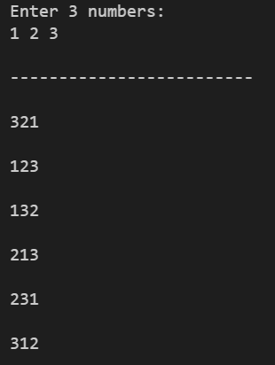 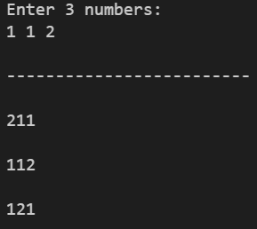 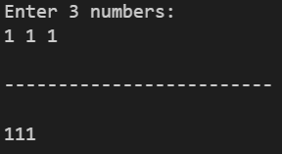

***NOTE-* The program takes care of repetition if digits are repeated**

**Exercise 2:** Write a Java Program to accept 10 numbers in an array and compute the square of each number. Print the sum of these numbers.

## Code:

import java.util.*;

public class SquareSum {

    void Square(int [] arr){

        int sum=0;

        System.out.print("---------------------------------\n");

        for(int i=0; i<arr.length;i++){

            sum += arr[i]*arr[i];

        }

        System.out.print("Sum: " + sum);

    }

    public static void main(String[] args){

        int[] arr;

        arr = new int[10];

        int c;

        Scanner sc = new Scanner(System.in);

        for (int i=0; i<arr.length;i++){

            c = i+1;

            System.out.print("Enter Number " + c + " : ");

            arr[i] = sc.nextInt();

        }

        sc.close();

        SquareSum obj = new SquareSum();

        obj.Square(arr);

    }

}

## Output:

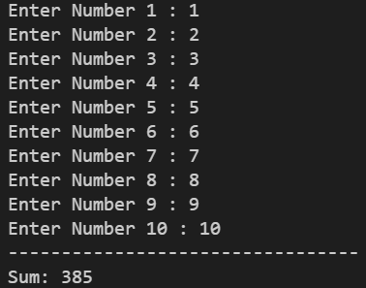

**Exercise 3** Write a program to input a number of a month (1 - 12) and print its equivalent name of the month. ( e.g 1 to Jan, 2 to Feb. 12 to Dec.)

## Code:

import java.util.*;

public class Month

{

    void InputMonth(int n)

    {

        switch (n)

        {

            case 1:

            {

                System.out.println("January");

                break;

            }

            case 2:

            {

                System.out.println("February");

                break;

            }

            case 3:

            {

                System.out.println("March");

                break;

            }

            case 4:

            {

                System.out.println("April");

                break;

            }

            case 5:

            {

                System.out.println("May");

                break;

            }

            case 6:

            {

                System.out.println("June");

                break;

            }

            case 7:

            {

                System.out.println("July");

                break;

            }

            case 8:

            {

                System.out.println("August");

                break;

            }

            case 9:

            {

                System.out.println("September");

                break;

            }

            case 10:

            {

                System.out.println("October");

                break;

            }

            case 11:

            {

                System.out.println("November");

                break;

            }

            case 12:

            {

                System.out.println("December");

                break;

            }

            default:

                System.out.println("Invalid Input");

        }

    }

    public static void main(String[] args)

    {

        Scanner sc = new Scanner(System.in);

        Month obj = new Month();

        System.out.print("Enter month number: ");

        int n = sc.nextInt();

        obj.InputMonth(n);

        sc.close();

    }

}

## Output:



**Exercise 4:** Write a program to find the sum of all integers greater than 40 and less than 250 that are divisible by 5.

## Code:

public class Divisibleby5 {

    public static void main(String[] args)

    {

        int sum=0;

        for (int i = 45; i <250; i+=5)

        {

            sum+=i;

        }

        System.out.println("Sum: " + sum);

    }

}

## Output:

